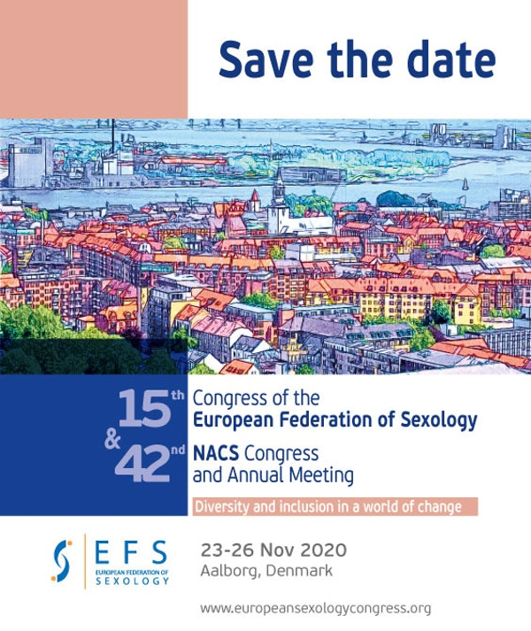

Mark your calendar for the 15th Congress of the European Federation of Sexology (EFS) & the 42nd Nordic Association of Clinical Sexology (NACS) Congress which will be taking place in Aalborg, Denmark from 23 to 26 November 2020.

Participating at the joint Congress in Aalborg Denmark is an opportunity to share and network with a truly multicultural audience from a variety of countries.

Registrations and Abstract Submissions will be available soon!

The conference website is now available at the following: www.europeansexologycongress.org

Should you have any inquiries, please send us an email or write us at:
74, Ethnikis Antistaseos str.
Sigma Block 1
Gr 55133, Kalamaria, Thessaloniki, Greece
we will be happy to assist.
Click here to unsubscribe

One-click Unsubscribe�

